Water movement through a drainage basin

**Student Handout: Activity 3.2 Page 1/2**

**Drainage basin definition:**

____________________________________________________________________________________

____________________________________________________________________________________

____________________________________________________________________________________ ___________________________________________________________________________________

Waterbodies in our community are part of the ___________________________ ocean drainage basin.

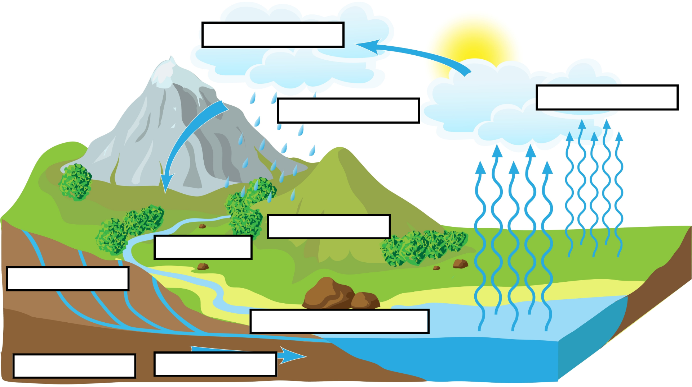

*See questions on the reverse side.*

Can pollutants released further away affect our water?

**Student Handout: Activity 3.2 Page 2/2**

**Go to Activity 2.4 in the** NPRI Student Dashboard**.** (<https://public.tableau.com/app/profile/ingenium5439/viz/NPRIStudentDashboard/Instructions>)

The map used in the NPRI Student Dashboard is subdivided by oceanic drainage basin. They are called “Oceanic” drainage basins since they eventually drain into oceans. Can you find our drainage basin on the map?

This map’s data has been filtered to only include releases to surface waters. It does not include disposals (e.g., underground injections, tailings ponds with the risk of failure), nor air/land releases. Do you feel that this map accurately captures all sources of water pollution? Justify your answer.

1. Are there pollutant-releasing facilities that you hadn’t noticed in the previous activity that might influence our water? If so, which ones? **Tip**: Zoom into the map to see the names of surrounding cities. _________________________________________________________________________
2. Could some of the facilities in our community be influencing the water of other towns and cities? If so, which ones? _________________________________________________________________________
3. What further information would we need to determine the potential spread by water? _________________________________________________________________________
4. If you oversaw creating environmental protection laws and policies for Canada’s waterbodies, would you push for international cooperation with other countries? Why or why not? _________________________________________________________________________
5. What can you infer about air and land pollution based on this exercise? _________________________________________________________________________